How to verify who imported a CR

Tx STMS_IMPORT

Click on the “Import History” button:

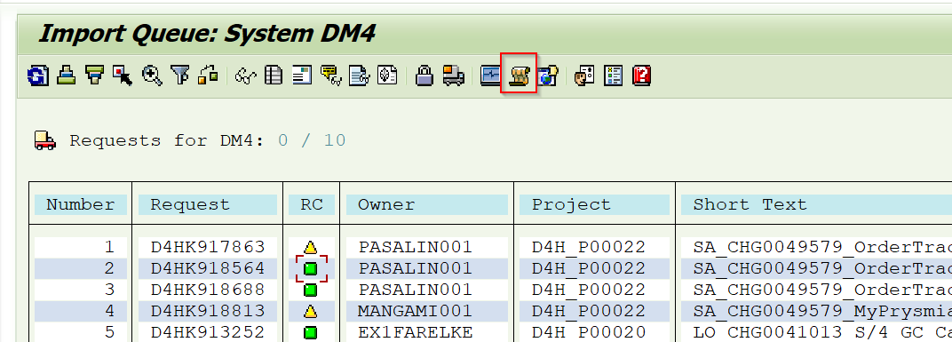

Select the “Time Interval”:

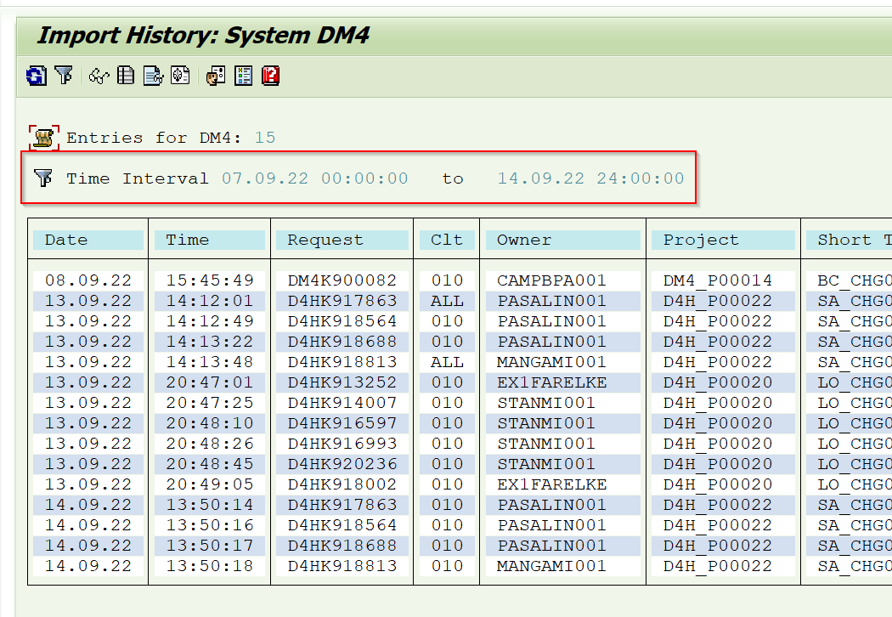

On the menu, select Edit -> Display More

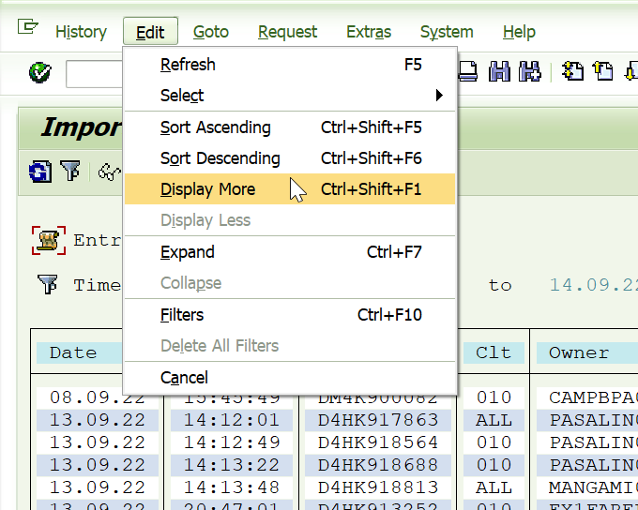

The system will show you who imported the CRs

